

**Jesus Heals People**

**Luke 4:38-40; 5:12-16**

When Simon’s mother-in-law is sick with a bad fever, Jesus heals her. People bring Jesus others who have many different diseases, and Jesus heals them just by touching them. Later a man with leprosy begs Jesus to heal him, and Jesus does. Jesus heals us!

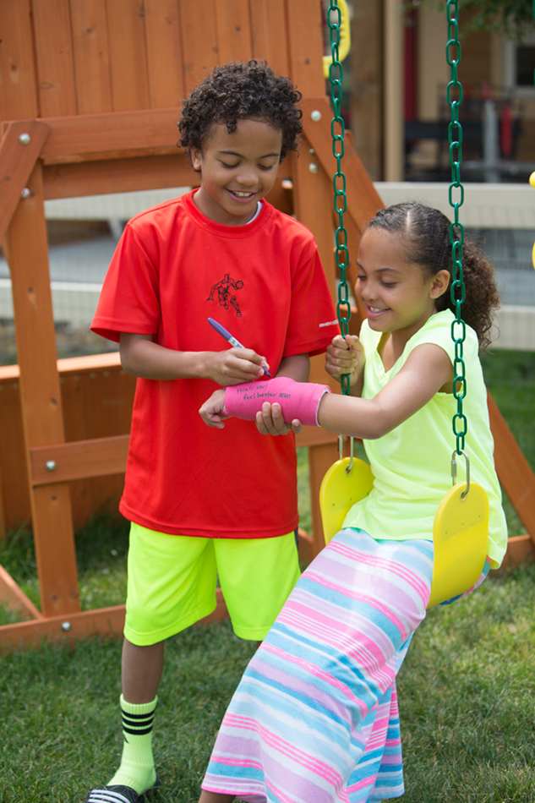

**Church Announcements**

* [Type your content here]

**Family Discussion**

* What’s the worst part about being sick?
* What helps you feel better when you’re sick?
* What’s a way you need Jesus to help you feel better?

*“No matter what their diseases were, the touch of his hand healed every one” (Luke 4:40).*

**Through the Week**

Here’s an activity you can do throughout the week.

* Get out several adhesive bandages.
* Each morning, choose the name of someone your family knows who needs healing—whether physical or emotional.
* Write that person’s name on a bandage for each family member.
* Have everyone wear the bandage throughout the day and pray for that person whenever they notice the bandage.

**Sick and Healed**

Play this fun game as a family to experience the power of healing.

* Decide on some challenges you can do such as: build a block tower, make a bed, move toys from one basket to another, or make sure all the lights are off. The challenges should be basic, everyday things.
* Give family members each a limitation such as having to cross their legs, keep their eyes closed, or keep one hand behind their back.
* Have everyone attempt to do the challenges with their limitations.
* Talk about how it felt to do those challenges with the limitation.
* Talk about how being sick or injured can limit us.
* Thank Jesus that he can heal us!